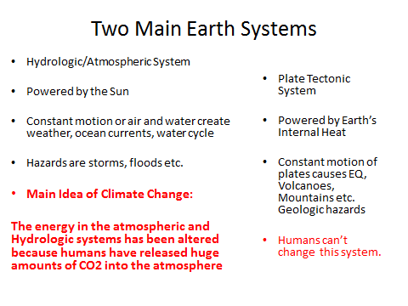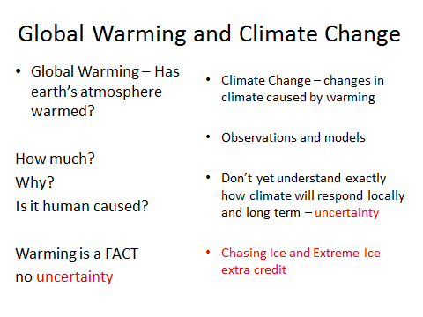

**Global Warming**

Summary of Lines of Evidence

Greenhouse Effect

Average heat from the sun has not changed

Humans add lots of CO2

Humans burn lots of carbon

Temperature measurements

Ice and sediment data

Model data matches measured data – can we extrapolate?

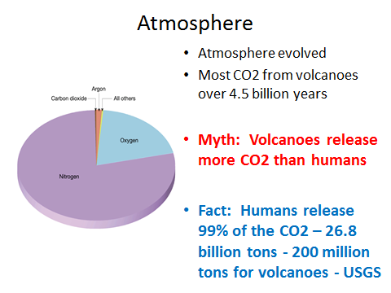

* The warming is occurring in the troposphere
* Other layers not affected
* Amount of radiation from the sun has not changed

**Greenhouse Effect**

* Earth’s atmosphere includes greenhouse gases carbon dioxide (CO2) and methane
* These gases absorb radiation/heat and warm the atmosphere.
* This is a natural process and the amount of CO2 is usually in balance.
* **Without a natural greenhouse effect, the temperature of the lower troposphere would be about zero degrees F (-18°C) instead of its present average 57°F (14°C). EPA**
* **https://www.youtube.com/watch?v=ZzCA60WnoMk**
* The sun heats the earth daily. At night the heat is released into space.
* CO2 gases trap heat in the lower atmosphere (troposphere).
* The more greenhouse gas, the more heat is trapped. Common sense…
* **Main Idea: Earth’s atmosphere heated by Greenhouse Gas.**
* **The more GG, the more heat is trapped.**
* **The amount of heat from the sun has not increased, but the temp of the atmosphere has increased – WHY – GH effect due to releases of CO2 by humans.**
* **CO2 is released by burning hydrocarbons**
* Pre-industrial levels of carbon dioxide were about 280 parts per million by volume (ppmv), and current levels are 400 ppmv and increasing at a rate of 1.9 ppm yr-1 since 2000.
* Based on ice core data, it is known that the global concentration of CO2 in the atmosphere far exceeds the natural range over the last 650,000 years of 180 to 300 ppmv.
* According to the IPCC Special Report on Emission Scenarios (SRES), by the end of the 21st century, we could expect to see carbon dioxide concentrations of anywhere from 490 to 1260 ppm (75-350% above the pre-industrial concentration).

**Sequestration**

* Plants remove CO2 from the air and use it to make plant material (carbon)
* We burn the carbon (coal) and put CO2 into the air
* <http://www.youtube.com/watch?v=JJxZH_Y5D4s>
* Fossil Fuels include oil, natural gas and coal. Contain high amounts of carbon and are hydrocarbons. Methane is CH4.
* Remains of organic matter (carbon) plants and animals. For example, plants take in CO2 and release Oxygen.
* 5 ft of plants = 1 ft of coal
* The carbon trapped
* http://www.youtube.com/watch?v=q3-dVHSm-24
* Humans use the huge reserves of old carbon (oil, oil, gas, coal) trapped in earth for millions of yrs
* By burning the carbon for energy we release the once trapped carbon in the form of CO2 into the atmosphere.
* http://www.youtube.com/watch?v=jc8mUI_cMKk
* This is why you sometimes hear people discuss climate change in terms of carbon and why energy use and climate change are so connected.
* Global Atmospheric (Troposphere) Warming resulting from human CO2 emissions is a measured, undisputed fact.
* The warming is about 1 degree F.
* http://www.youtube.com/watch?v=S9ob9WdbXx0
* National Academy of Sciences - “:Earth's surface temperature has risen by about 1 degree Fahrenheit in the past century, with accelerated warming during the past two decades.” <http://www.policyalmanac.org/environment/archive/climate_change.shtml>
* Summary – As CO2 concentrations rise, so does the temperature. This increase in temperature affects, pressure and air flow in the atmosphere. Over time, these differences in temperature, pressure etc., mean changes in the climate.
* 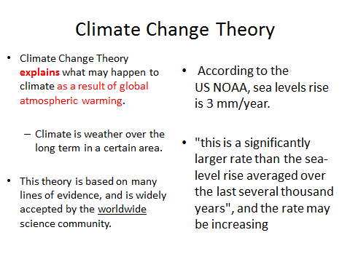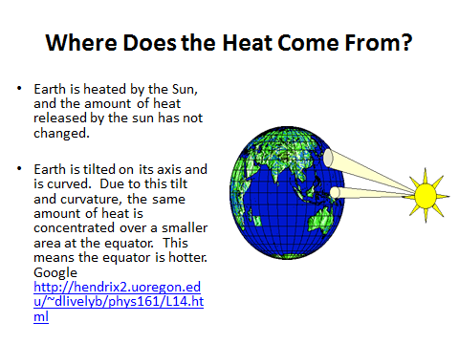
* This difference in heat between the hot equator and the cold poles creates a heat flow gradient. This causes hot air to move towards the cold poles
* (e.g., heat from an oven comes out and spreads through a room – cooling the inside of the oven).
* This heat flow involves the movement of huge volumes of air and creates climate systems.
* **Changes Wind Patterns and Pressure (Climate)**
* Hadley cells show how heat and air flows, and show how winds are created as heat moves from the equator to the poles: Google Images <http://www.google.com/imgres?q=hadley+cells+and+heat>
* Natural processes (photosynthesis, respiration, decomposition etc.) related to plants and the ocean keep CO2 concentrations in balance. A one degree increase in the temperature of the entire atmosphere due the GE represents a huge amount of additional heat/energy in the atmosphere.
* The additional heat affects the heat flow between the equator and the poles. This change in heat has an impact on climate.
* The main idea is that heat flows from the equator to the poles, and the more heat the more flow. More heat affects the air flow, winds, pressure and climate.
* About ½ the human released CO2 is dissolved in the ocean. However, large volume human CO2 releases are causing warming. USEPA
* Fossil fuels (coal and oil) used to run cars and trucks, heat homes and businesses, and power factories are responsible for about 98% of U.S. carbon dioxide emissions.
* It is estimated that by 2100, in the absence of emissions control policies, carbon dioxide concentrations will be 30-150% higher than today’s levels. What effect will this have??? USEPA -

**Paleoclimate**

* Studies of Paleo or ancient climate sensitive sediments and chemicals (carbonate) in very old natural lakes such as Utah’s Bear Lake and Great Salt Lake indicate climate changes naturally.
* However, studies show current warming and climate change is occurring at a faster rate than natural. <http://epa.gov/climatechange/science/pastcc.html>
* Antarctic Ice is miles thick and possibly 1.5 million years old
* Each year new snow builds and forms ice
* The ice contains H, ), dust, pollen, volcanic ash, and air bubbles from when it formed
* Oxygen comes in several isotopes and the amount of each isotope tells us about climate of the past
* Ice core inclusions (dust, etc.) are proxies for temperature, ocean volume, precipitation, chemistry and gas composition of the lower atmosphere, volcanic eruptions,
* Proxy data show over the last 400,000 years atmospheric CO2 levels have fluctuated between 180 and 280 parts per million by volume (ppmv), corresponding with conditions of glacial and interglacial periods.
* Today we are at 400 ppmv, the highest in 400,000 years..
* https://www.youtube.com/watch?v=oHzADl-XID8
* **Human impact is clear**

**Hazard, Risk and Vulnerability**

* Climate change is a world-wide phenomenon. We don’t know exactly what the local hazards will be or who will be affected the most.
* There are more uncertainties related to climate change on a local basis than other geological type hazards because it is a global phenomenon.
* Should we plan for a climate change when we do not know exactly who may be affected and how big the affects will be?
* Can we buy Insurance ????
* Four outcomes:
* no insurance/no action and no problems,
* no insurance/no action and yes a problem (worst case scenario)
* Insurance/no action and no problem
* Insurance/no action and - yes a problem
* **Can’t eliminate all uncertainty, but you can make decisions based on what you know. In this case, we know warming will cause climate change**
* Models are used to make predictions. <http://www.youtube.com/watch?v=S9ob9WdbXx0>
* Risk - Losses that may occur due to hazards. Think like an insurance agent. Replacement costs.
* If climate change causes a wetland to go dry, and ducks have no home, what is the risk/loss? How much is a duck worth? It is worth the cost of replacing lost habitat.
* If the ski industry dries up – what are the costs for Utah?

**Climate Change Deniers**

* Political groups, politicians and industry use TV (Fox News etc.) and the Internet to create doubt and confusion Climate theory. See Merchants of Doubt by Naomi Oreskes - <http://www.merchantsofdoubt.org/>
* Raising doubt causes people to hesitate in making decisions, and prevents government regulation.
* The same groups raising doubt about climate change also raised doubt about tobacco, ozone and DDT. Today, most people agrees tobacco, ozone, etc., need regulation. So does CO2.
* **Credible Sources**
* <http://www.epa.gov/climatechange/>
* [http://www.climate.gov/#climateWatch](http://www.climate.gov/)
* <http://www.ipcc.ch/>
* <http://www.usgs.gov/climate_landuse/>
* <http://ec.europa.eu/clima/policies/eccp/index_en.htm>
* [http://www.ncdc.noaa.gov/oa/climate/globalwarming.html#q1](http://www.ncdc.noaa.gov/oa/climate/globalwarming.html)
* “There is no proof that global warming will cause a mega-drought, or a sudden sea level rise. There is only a reasonable argument based on common sense. “
* “We have learned that earth’s climate has been capable of mega-droughts and other extreme and abrupt fluctuations in the past, when given only a small push by the **sun.** It seems prudent to avoid giving climate a big push. If you’re living with an angry beast, you shouldn’t poke it with a sharp stick.”
* **Wallace Broecker, Geologist**
* **Author of: Fixing Climate, What Past Changes Reveal About the Current Threat**
* CO2 regulated and treated the same as sewage
* Sewage is regulated, collected and treated
* We can also regulate, collect and treat the CO2.
* This will be a massive effort, but has less impact because it does not limit industry and simpler less political solution.